Task 2: Launch Two EC2 Instances Running a Web Server
Objective
Launch two Amazon EC2 instances using Amazon Linux 2, install the Apache web server (httpd), and verify that both servers are accessible using their public IP addresses.
Steps Performed
- Logged in to the AWS Management Console.
- Opened the EC2 Dashboard.
- Launched two Amazon Linux 2 EC2 instances.
- Selected t2.micro instance type.
- Allowed HTTP (Port 80) and SSH (Port 22) in the Security Group.
- Connected to each instance using SSH.
- Installed the Apache web server using the following commands:
sudo yum update -y
sudo yum install httpd -y
sudo systemctl start httpd
sudo systemctl enable httpd
- Created a different homepage on each server.
Instance 1
echo "<h1>Welcome to Web Server 1</h1>" | sudo tee /var/www/html/index.html
Instance 2
echo "<h1>Welcome to Web Server 2</h1>" | sudo tee /var/www/html/index.html
- Opened the public IP address of both instances in a web browser.
Result
Both EC2 instances were successfully launched and the Apache web server was running. Accessing the public IP of each instance displayed its respective webpage.

Task 2: Configure an Application Load Balancer (ALB)
Objective
Create an Application Load Balancer to distribute HTTP requests between the two EC2 instances.
Steps Performed
- Opened the EC2 → Load Balancers section.
- Selected Create Load Balancer.
- Chose Application Load Balancer.
- Configured:
  - Internet-facing
  - IPv4
  - HTTP (Port 80)
- Selected the required VPC and Availability Zones.
- Created a Target Group using the two EC2 instances.
- Registered both EC2 instances with the Target Group.
- Created the ALB.
- Opened the ALB DNS name in the browser.
Result
The Application Load Balancer successfully distributed incoming requests between both EC2 instances. Refreshing the browser displayed responses from Web Server 1 and Web Server 2.

Task 3: Configure Health Check with Custom Path
Objective
Configure the ALB health check to use the /health endpoint.
Steps Performed
On Both EC2 Instances
Created a health check page.
echo "Healthy" | sudo tee /var/www/html/health
In AWS
- Opened the Target Group.
- Selected Health Checks.
- Changed the health check path from:
/
to
/health
- Saved the configuration.
- Waited for the health status to update.
Result
Both instances returned HTTP 200 OK for the /health endpoint and were marked Healthy by the Application Load Balancer.

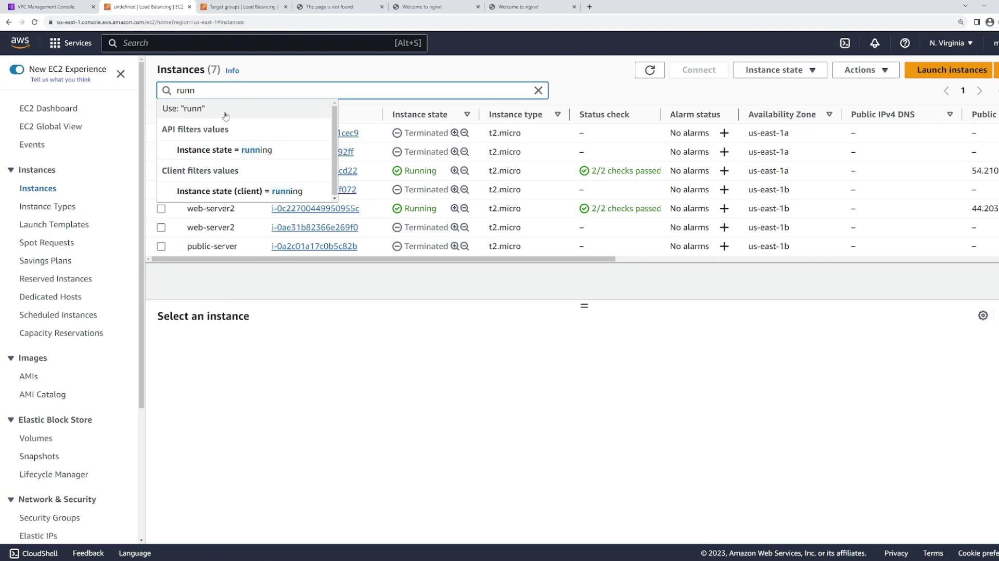

Task 4: Simulate Server Failure
Objective
Observe how the ALB behaves when one server becomes unavailable.
Steps Performed
- Stopped one EC2 instance from the EC2 Console.
- Waited until the health check marked the instance as Unhealthy.
- Refreshed the ALB DNS URL several times.
Observation
- The stopped instance failed the health checks.
- The ALB automatically removed it from the list of available targets.
- All incoming requests were routed only to the healthy EC2 instance.
- Users continued accessing the application without interruption.
Conclusion
This demonstrates High Availability because the Application Load Balancer automatically detects unhealthy servers and redirects traffic only to healthy instances, ensuring uninterrupted service.

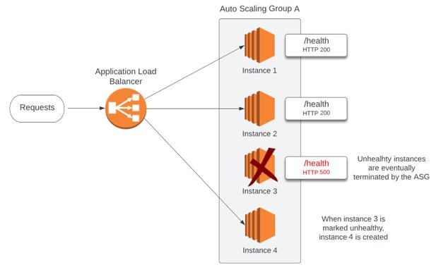
Task 5: Comparison of AWS Load Balancers
Feature | Application Load Balancer (ALB) | Network Load Balancer (NLB) | Classic Load Balancer (CLB)
Supported Protocols | HTTP, HTTPS, WebSocket, HTTP/2 | TCP, UDP, TLS | HTTP, HTTPS, TCP
OSI Layer | Layer 7 (Application Layer) | Layer 4 (Transport Layer) | Layer 4 & Layer 7
Best Use Case | Web applications and microservices | High-performance applications and gaming | Legacy AWS applications
Routing Features | Path-based and Host-based routing | Routes based on IP and Port | Basic routing only
Performance | High | Very High | Moderate
Health Checks | Advanced health checks | Basic health checks | Basic health checks
Target Types | EC2, IP, Lambda, Containers | EC2 and IP | EC2 only
Recommended By AWS | Yes | Yes | No (Legacy Service)
